**EX19Install a C compiler in the virtual machine created using virtual box / VM Ware Workstation / Player and execute Simple C Programs**

**AIM:**

To Install a C compiler in the virtual machine created using virtual box / VM Ware Workstation / Player and execute Simple C Programs.

**PROCEDURE:**

**STEP 1:**

First install VMware workstation in your pc/laptop. Then open the VM software and click create a new virtual machine displayed on a home tab.

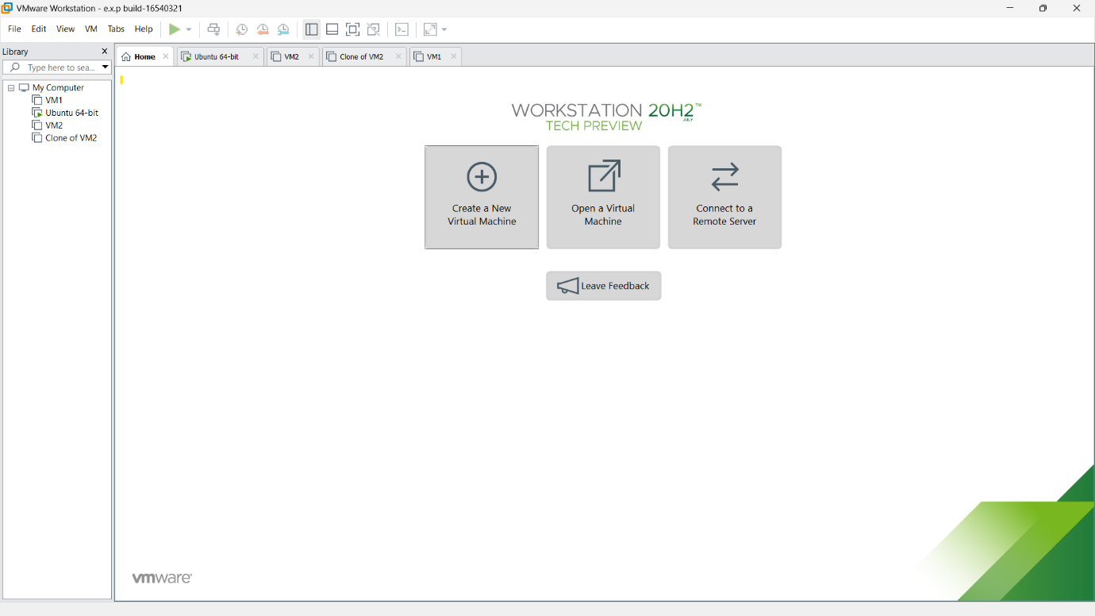

**STEP 2:**

Then open any created and installed OS of VM like linux,ubuntu etc….

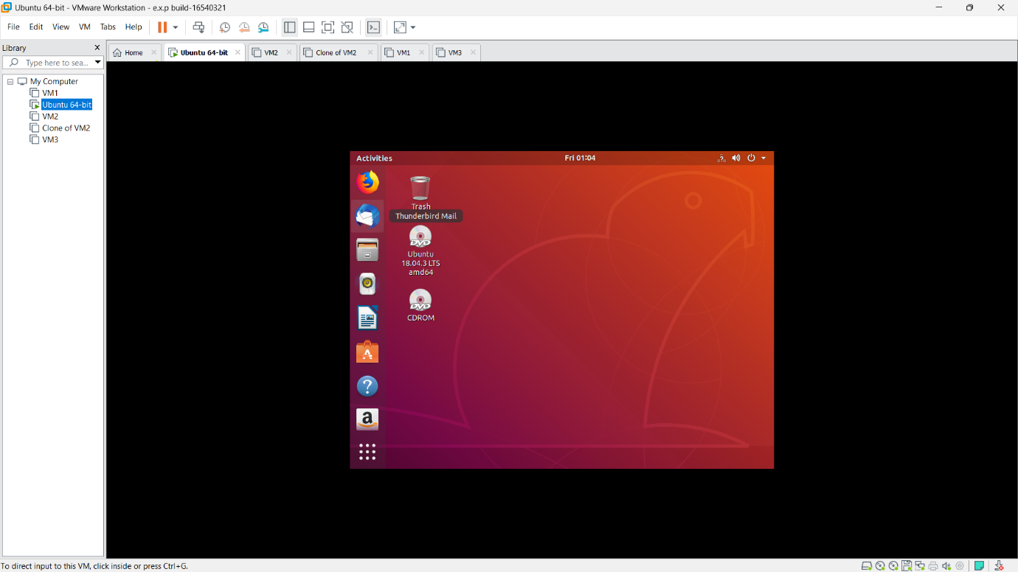

**STEP 3:**

Then click ctrl+alt+T. terminal will be opened and install the c program terminal by entering” sudo apt-get install build-essential”. Then provide the essential credentials. C program terminal will be started to download.

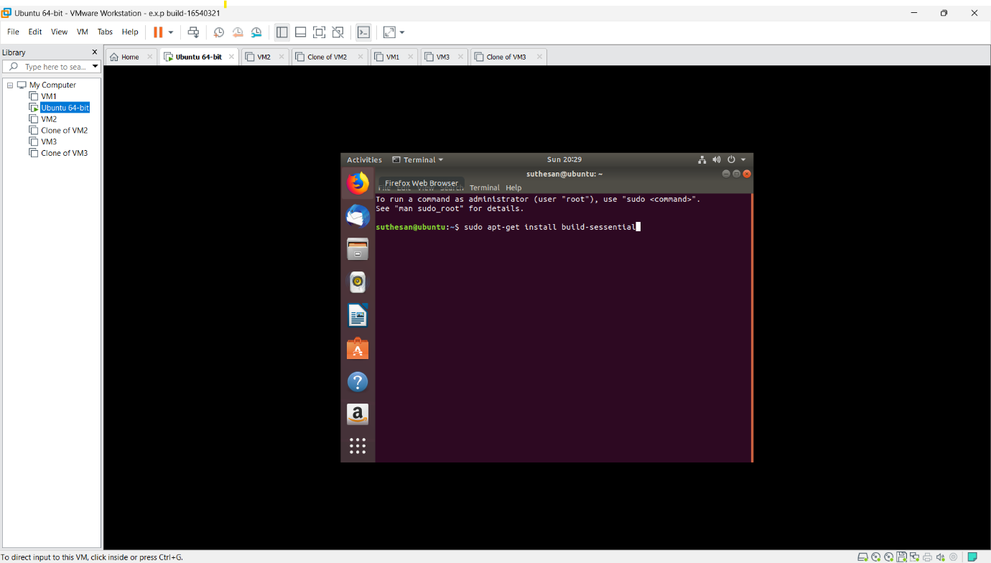

**STEP 4:**

Installation process will be continued.

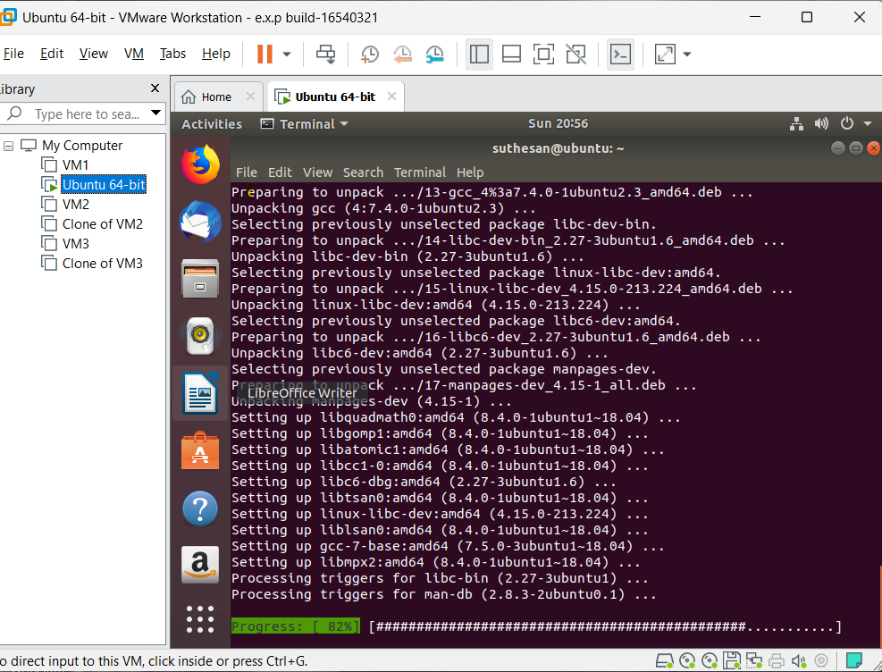

**STEP 5:** then type get first.c in terminal to type the code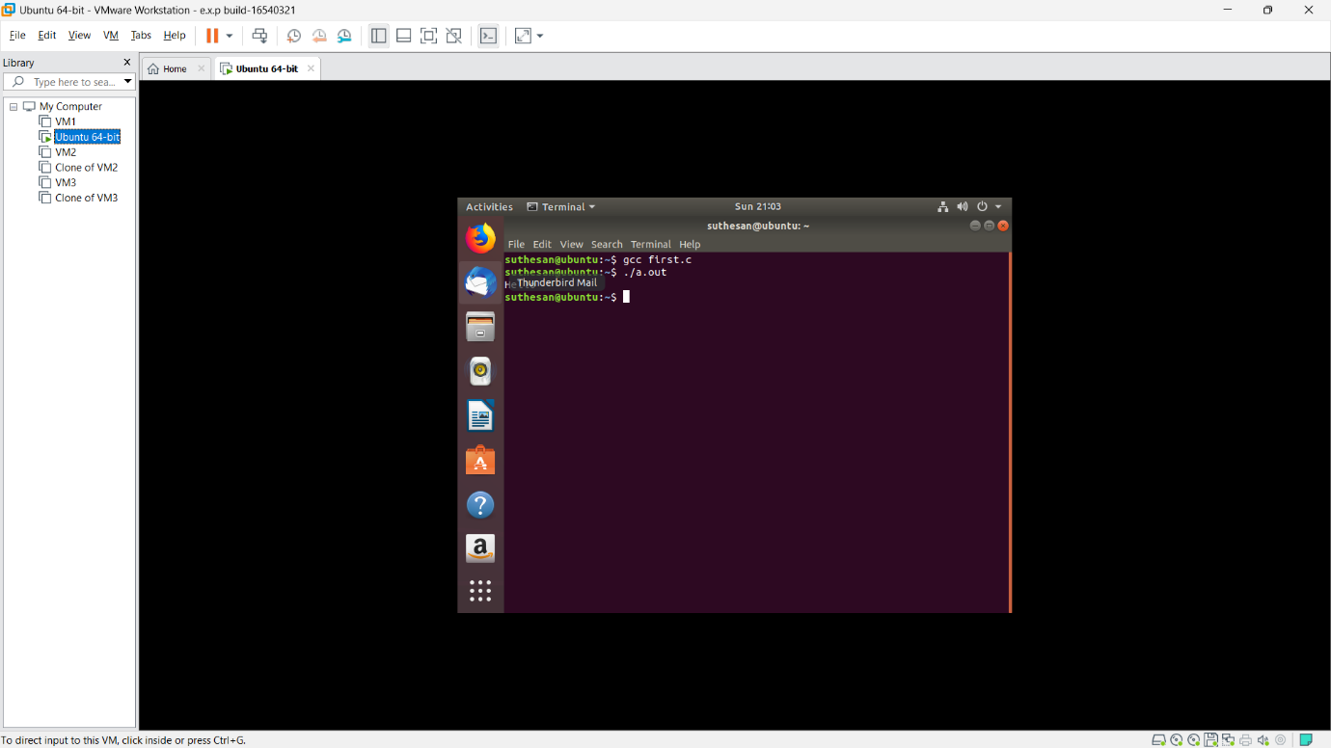

**STEP 6:**

then type the code and save it.

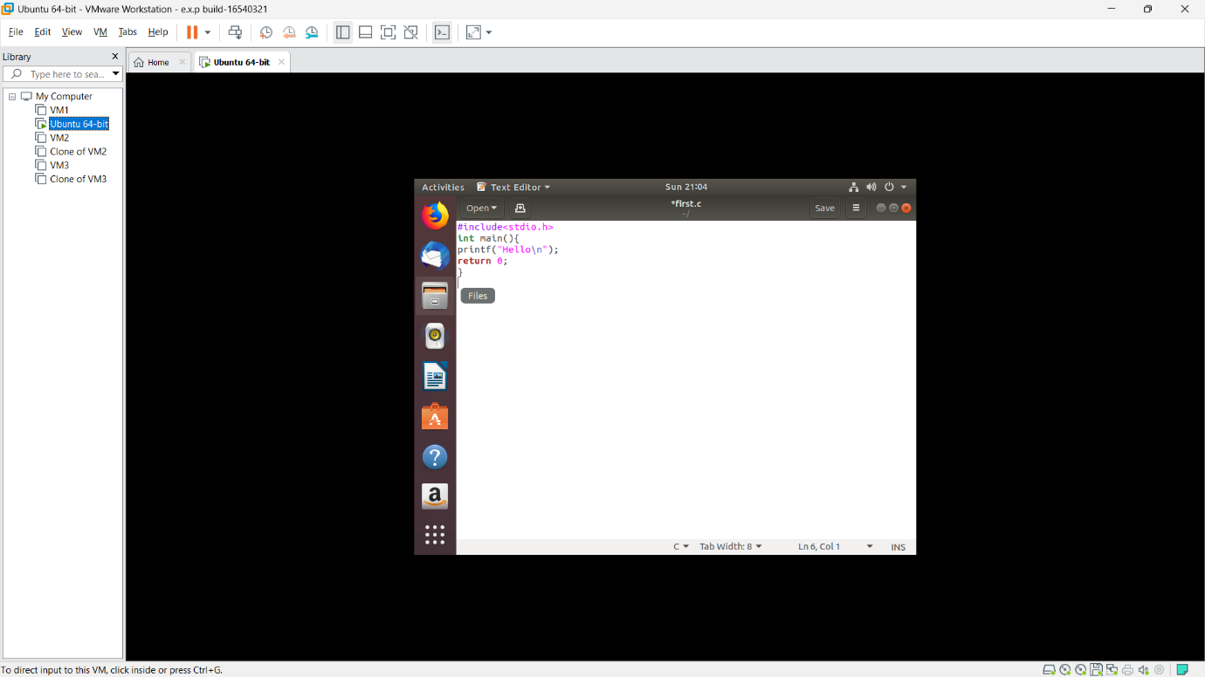

**STEP 7:**

Again open the terminal and type gcc first.c  
output will be shown.

